**FICTION** Summer Reading Assignment **FICTION** Summer Reading Assignment

**FICTION REVIEW POST-ITS**

* You will be reviewing your book in order to find evidence/examples that support the prompt you will select from the choices below. Find **FOUR** pieces of textual evidence that help to illustrate the prompt you choose. Mark each piece of evidence with a post it, and do the following:
* Put the book’s the page number on the post it
* Label the post it according to the prompt (conflict, character change, setting, or symbol).
* Explain (on the post it) in 3-4 ***full sentences*** how the evidence is significant in speaking to the prompt you select.

**FICTION PROMPTS**

Put a check mark in the box next to ONE prompt your post it notes will respond to.

* What’s the major **CONFLICT** (internal or external?) in the novel? Look, too, for how it is or is not resolved.
* Choose one significant character in the novel. Look for evidence of who this character is at the start and who he/she is by the end. How does the **CHARACTER CHANGE**?
* Explain about the **SETTING** (time and/or place) and think about how that matters to the section of the story.
* What is a **SYMBOL** in the book? How/why is that symbol important to the story?

**FICTION REVIEW POST-ITS**

* You will be reviewing your book in order to find evidence/examples that support the prompt you will select from the choices below. Find **FOUR** pieces of textual evidence that help to illustrate the prompt you choose. Mark each piece of evidence with a post it, and do the following:
* Put the book’s the page number on the post it
* Label the post it according to the prompt (conflict, character change, setting, or symbol).
* Explain (on the post it) in 3-4 ***full sentences*** how the evidence is significant in speaking to the prompt you select.

**FICTION PROMPTS**

Put a check mark in the box next to ONE prompt your post it notes will respond to.

* What’s the major **CONFLICT** (internal or external?) in the novel? Look, too, for how it is or is not resolved.
* Choose one significant character in the novel. Look for evidence of who this character is at the start and who he/she is by the end. How does the **CHARACTER CHANGE**?
* Explain about the **SETTING** (time and/or place) and think about how that matters to the section of the story.
* What is a **SYMBOL** in the book? How/why is that symbol important to the story?

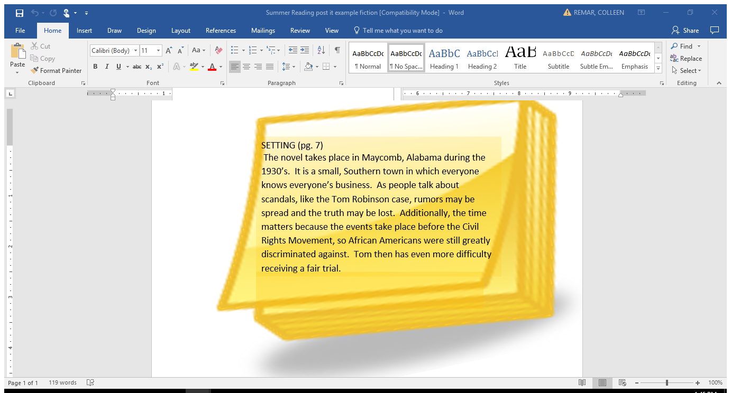

**SAMPLE POST IT**

**SAMPLE POST IT**